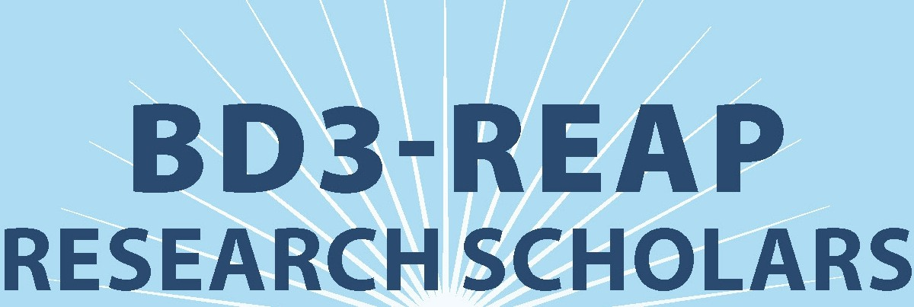
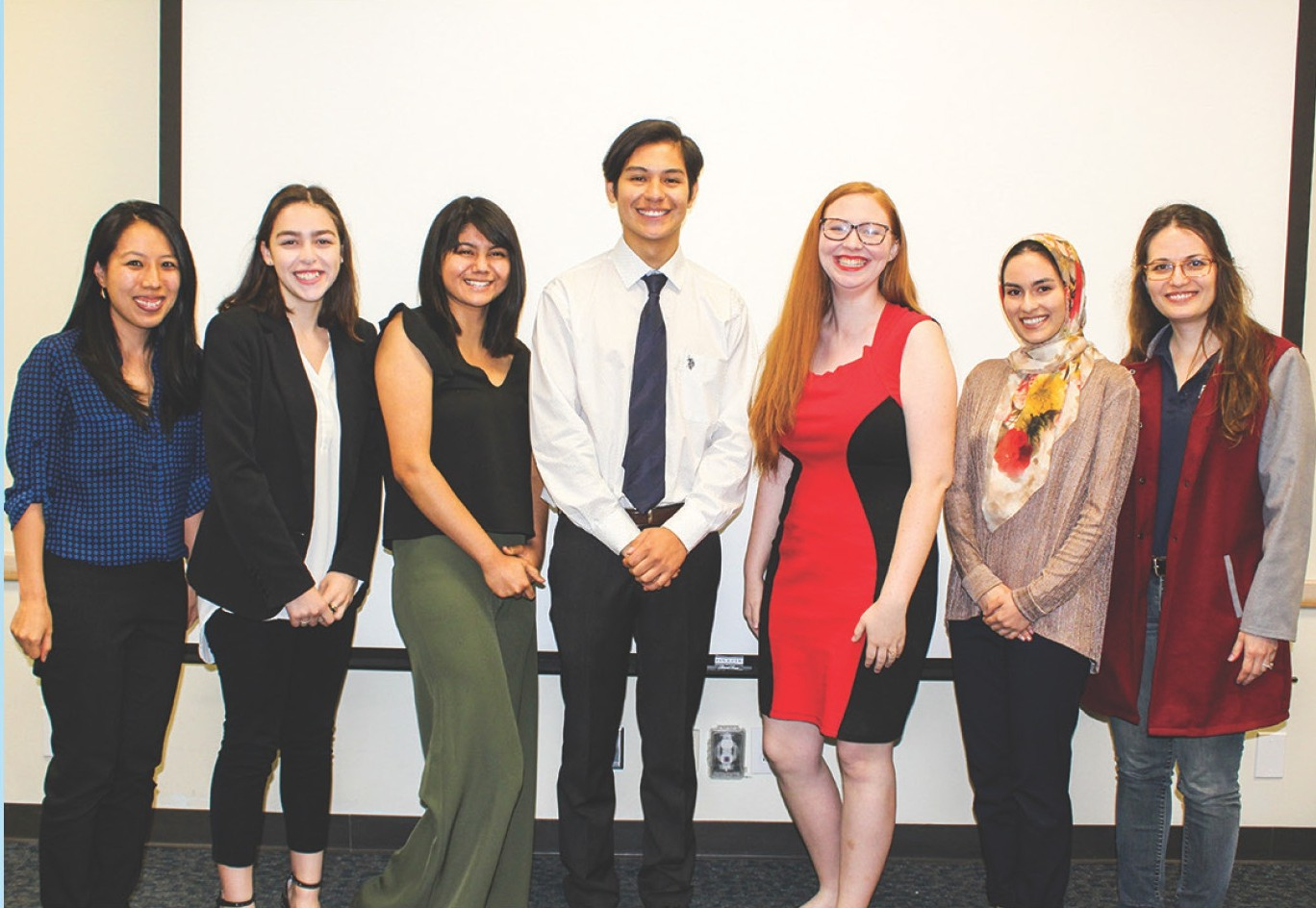
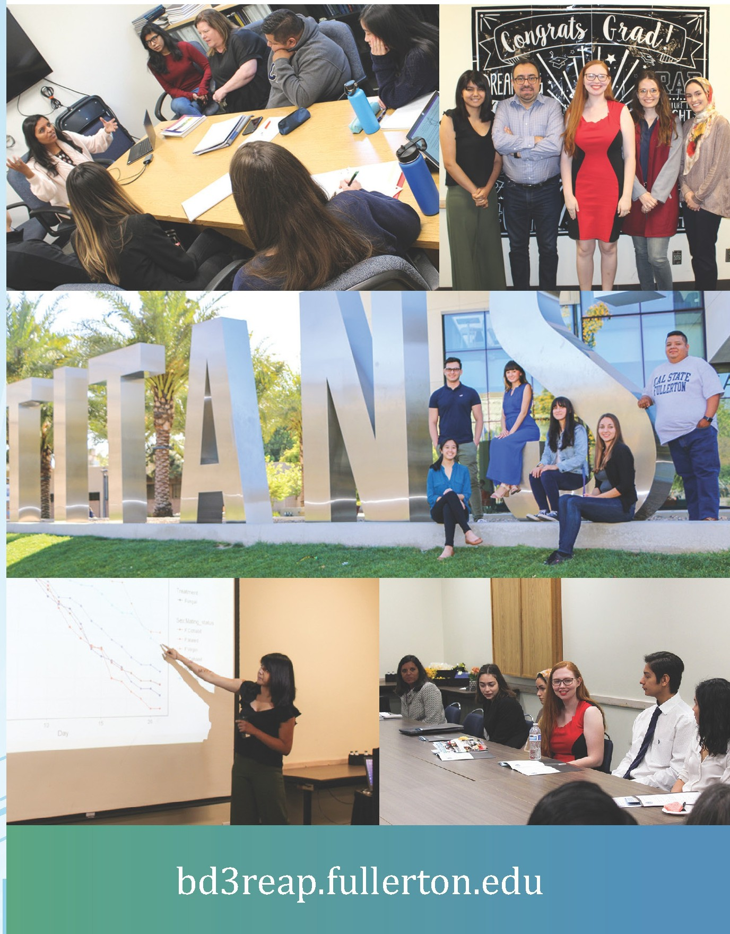

2019 GRADUATES

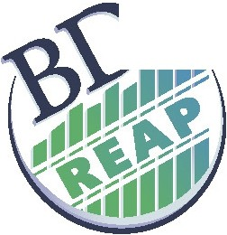
Big Data Discovery & Diversity
?.,
THROUGH RESEARCH EDUCATION ADVANCEMENT AND PARTNERSHIP

2019COHORT

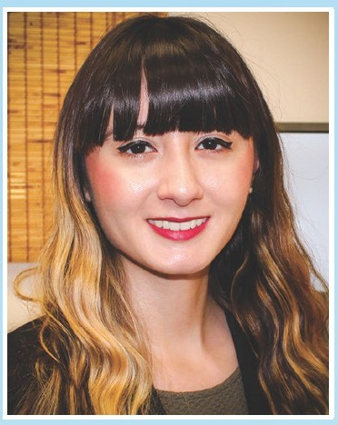
Alyssa Bright
Major: Computer Science
Alyssa is investigating the relationship between physical activity and sedentary behavior on high blood pressure in the adult Asian-American population using the 2015-16 NHANES database. She hopes to encourage further research on high blood pressure in Asian-American adults.

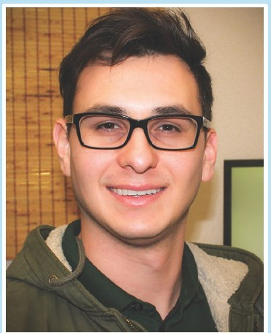
Brandon Tomich
Major: Computer Science
Brandon's current research interests include adversarial neural networks and cloud computing. He is currently using data science to find solutions to current challenges faced in discovering different compounds related to a chemical structure known as perovskites.

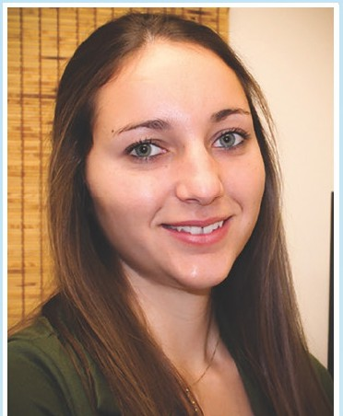
Gwendolyn Lind
Major: Mathematics
Gwendolyn is addressing whether alcohol use, smoking, and caffeine consumption are associated with physical activity/sedentary behaviors. Her potential research interests at USC include multi-scale entropy analysis and functional connectivity analysis.

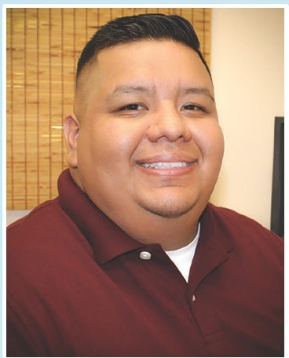
Juan Cabrera
Major: Statistics
Juan's research consists of finding predictors that are necessary for a robust synthesis­ structure prediction, particularly in the perovskite structure. His research interests also include statistics, data mining, data visualization, machine learning, neural networks, deep learning, and artificial intelligence.

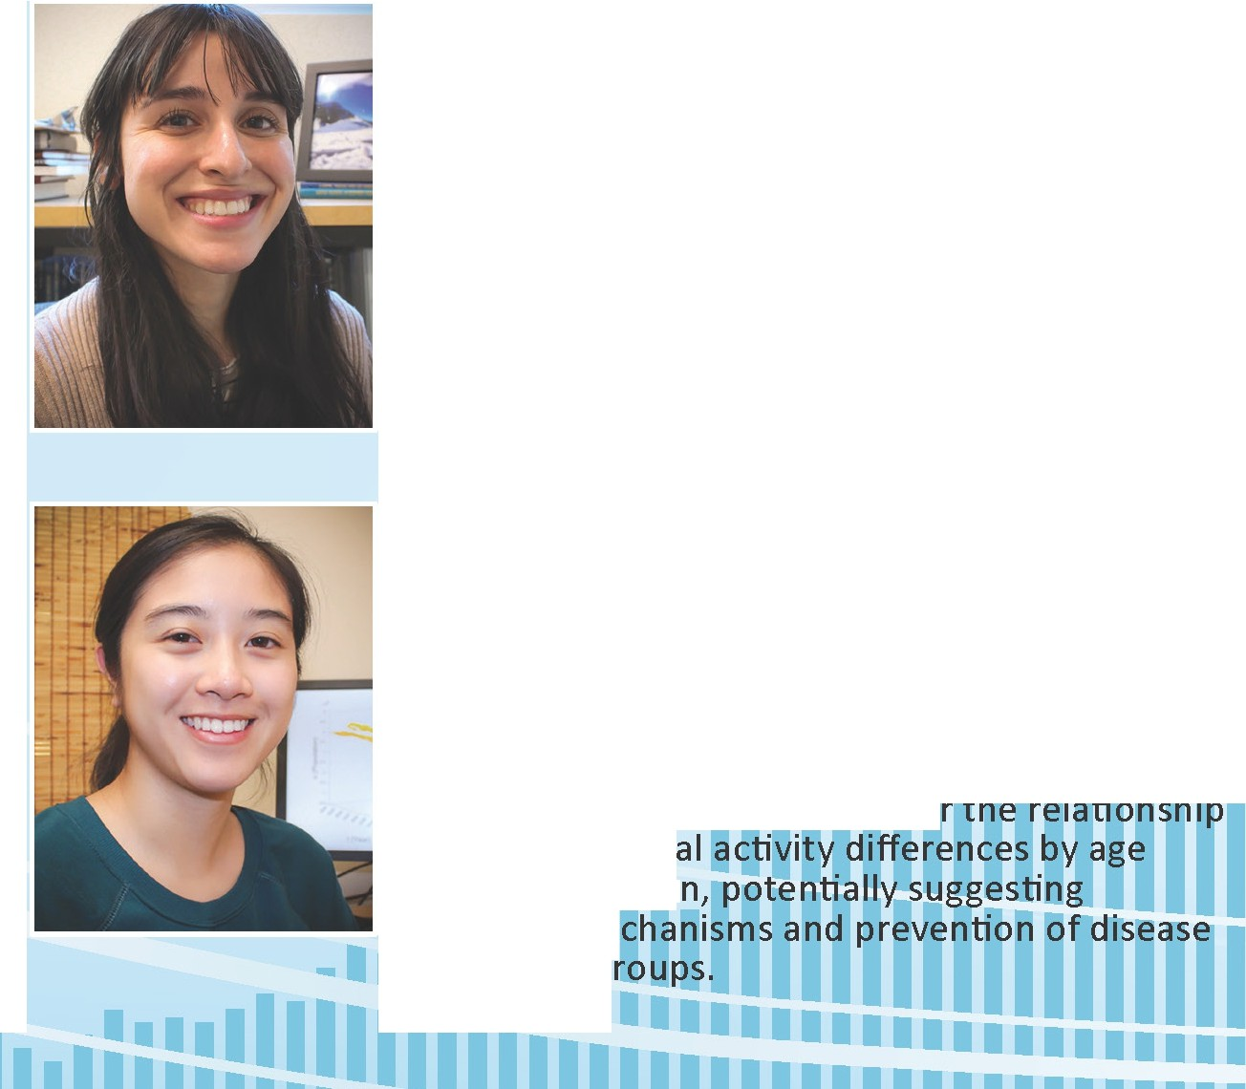
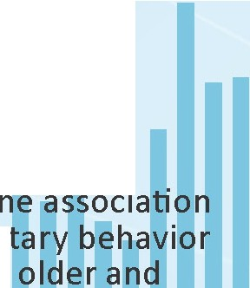
Maria Diaz
Major: Computer Science
Maria's research is in the Fry-Petit lab where my team is currently learning about machine
learning as a way to predict perovskite materials that will contain the desired properties. Her research interests are data science, machine learning algorithms and their scale-ability to combat societal problems.

Mimi Ngo
Major: Public Health
Mimi's research is focusing on t • between physical activity/seden
and metabolic syndrome among
younger women. Mimi works wi and
McEligot aims to assess whethe • between physic
groups in wome different me
in the two g

GRADUATING
SCHOLARS

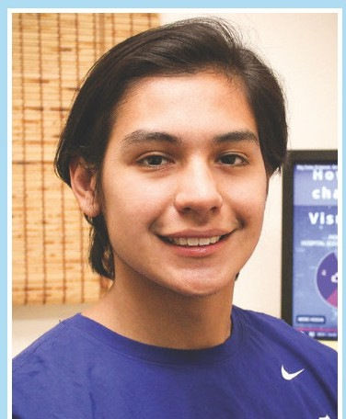
Alexander Aguilar
Alexander's research project at CSUF involved studying the evolutionary trade-offs that occurrs in experimentally evolved fruit flies. The findings showed that longevity and immune defense were transient trade off traits depending on selection of the fruit flies. This research furthers the knowledge of fruit flies having practical uses such as pest and disease control.
Alexander's research project at USC was on improving data visualization of complex neural
networks using gaming software. He used Unity, a gaming developer software, to create a supplementary interactive webpage portraying the hippocampus network connections of a mouse brain. Furthermore, he used Unity to create 3D images of 2D MRI brain scans.
Alexander is currently an intern at the Center for Health Statistics and Informatics in Sacramento for the California Department of Public Health. He is applying for graduate programs and hoping to start in the Fall of 2020 where he plans to get into a program for a MPH in epidemiology.

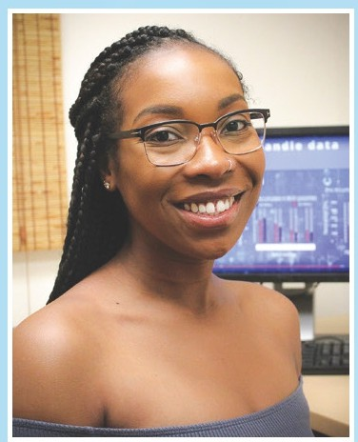
Cydney Parker
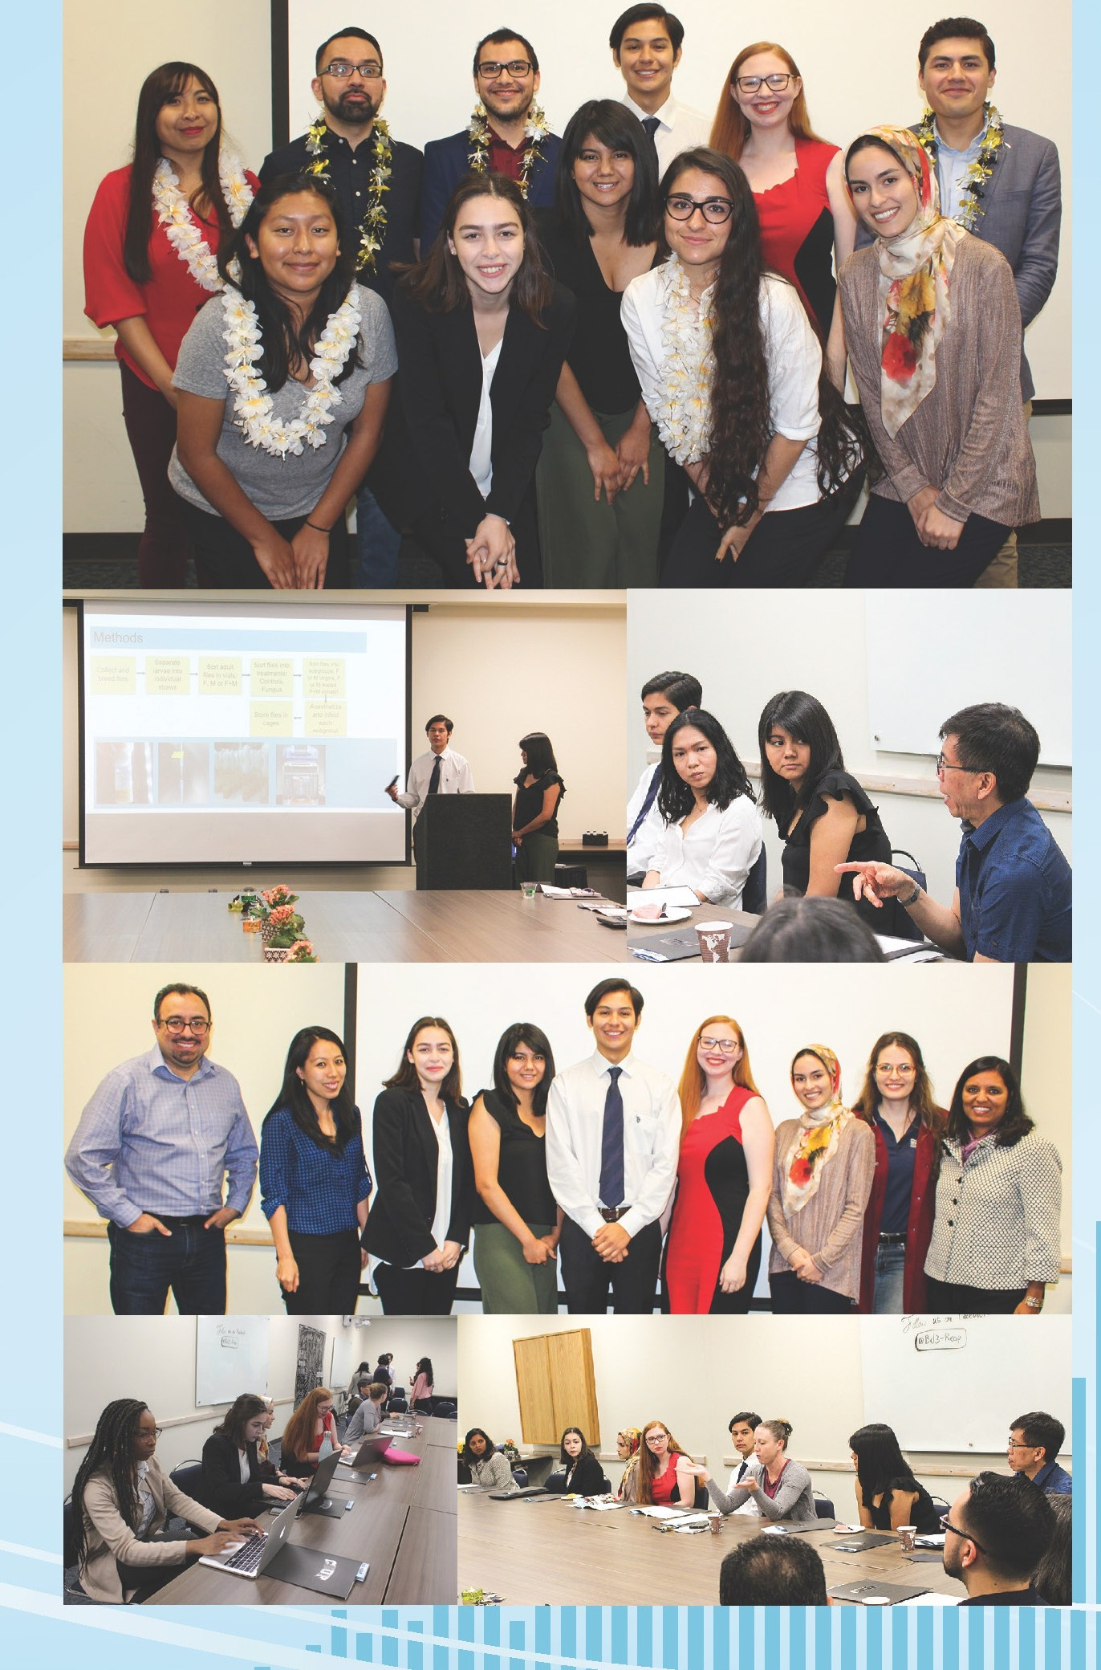
At CSUF, Cydney worked with Dr. McEligot, Dr. Lee, and Dr. Poynor on a cross-sectional epidemiological study. She looked at the relationship between phytoestrogens and ovarian cancer using a large national data set, National Health and Nutrition Examination
Survey (NHANES). Initial findings demonstrated that one of the six phytoestrogens analyzed was associated with disease outcomes, while two had borderline significance, potentially
suggesting that phytoestrogens may influence ovarian cancer outcomes, but further research needs to be conducted.
At USC, Cydney worked with Dr. Dominique Duncan to identify possible biomarkers for epileptogenesis after a traumatic brain injury(TBI) in animal models and patients. To become familiar with the subject, she researched TBl's and Post Traumatic Epilepsy in association with post­ traumatic seizures. She also analyzed EEG data using two of Matlab's toolbars, ripplelab and EEG lab to identify High Frequency- Oscillations, which are potentially promising biomarkers for epileptogenesis.
After carefully considering graduate school options, Cydney chose to pursue a master's degree in Public Health at Emory University in Atlanta, Georgia with a concentration in Behavioral Science and
Health Education. The primary aim of her research is to look at health disparities in underrepresented communities. She plans to focus on public health nutrition and food insecurities in minority communities as well as the effects of nutrition on cancer in minority populations. Upon completion of graduate school, she would like to gain experience in
the workforce as a Health Scientist at the CDC and eventually pursue a Ph.D.

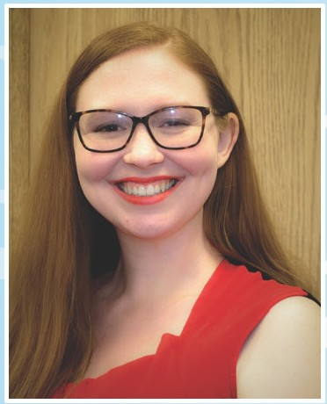
Melissa Riddle
Under Dr. Parvin Shahrestani, Melissa researched the relationship between starvation resistance and survival in Drosophila melanogaster (fruit flies). At USC, she
researched the relationship between Alzheimer's diagnosis and brain complexity. Her current research projects are exploring the relationship between genetics, inheritance, and survival in Drosophila melanogaster under Dr. Shahrestani and investigating the relationship between
intoxication and brain waves under Dr. Doina Bein.
Melissa is graduating with a B.S. in Computer Science and a B.A. in Pure Mathematics this Summer 2019. She plans to immediately enter the workforce and attend graduate school within the next few years.
II

Nayelie Benitez
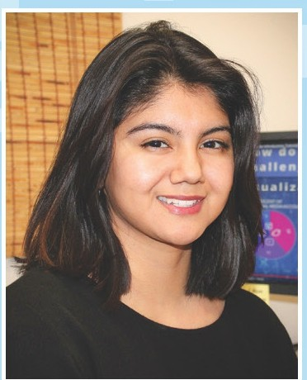
Nayelie performed image processing using programming languages in the lab of USC professor, Dr. Braskie, to further investigate
the association of certain health conditions and their prevalence in the the Mexican-American community and associated risk factors with Alzheimer's. With the guidance of her mentors Dr. Behseta and Dr. Shahrestani at CSUF, she is writing a journal article to publish the findings from research on the evolutionary trade-offs in
D.Melanogaster. She plans on attending UCLA in the fall of 2019 to earn her MS degree in Epidemiology and hopes to research the effects of environmental exposures on human health, such as chronic diseases.

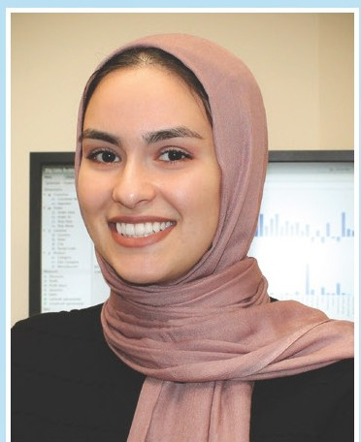
Nooralhoda Sadeghi
Nooralhoda is working with Dr. Kay Jann at USC studying functional connectivity (FC) and multiscale entropy (MSE) of the brain
using a dataset from the Human Connectome Project. They are researching to see if brain networks found using MSE are similar to FC brain networks, and if these networks can be correlated to higher cognitive tasks. Currently, their work is in preparation for a publication.
After graduating this spring, she plans on attending a computational biology Master's program in the Fall.

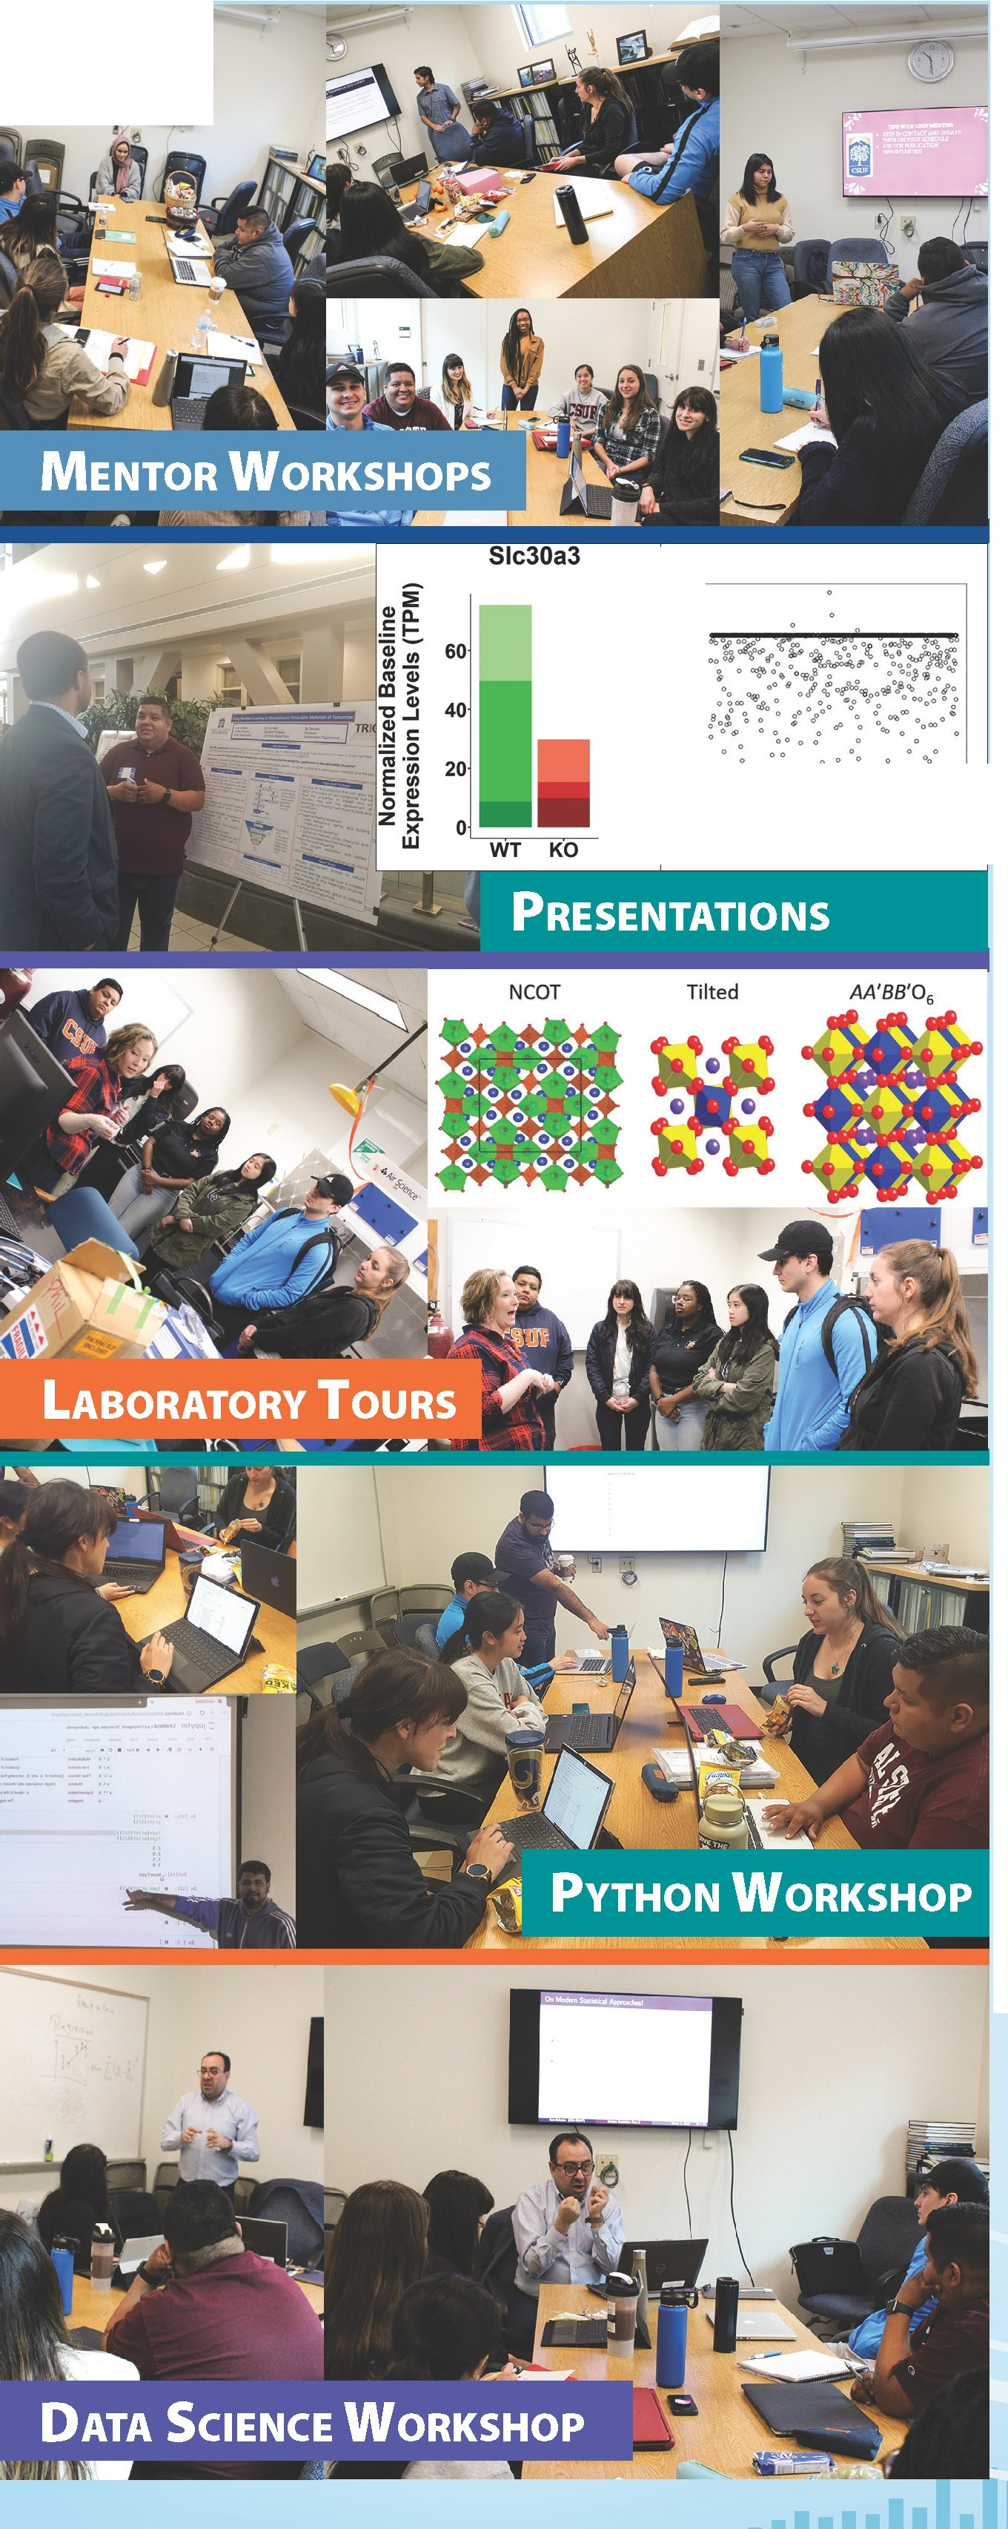
STUDENT ACTIVITIES
•

K01 K02 K03 WT1
;

STUDENT ACHIEVEMENTS

- Amber Cornelious
University of Southern California

Alexander Aguilar
Center for Health Statistics and lnfro atics,
California D@par,tm@nt Qf RubliG lcl@altl;\

Shaina Sta. Cruz
University of California, Merced

UNIVERSITY

CALIFORNIA
UNIVERSITY OF CALIFORNIA

MERCED

Jonathan Chacon
California State University, Fullerton

Silvia Orozco
Univeristy of Chicago

Nayelie Benitez
University of California, Los Angeles

UNIVERSITY

Ml
CALIFORNIA

UCLA

Cydney Parker
Emory University

Stephen Gonzalez
University of Southern California

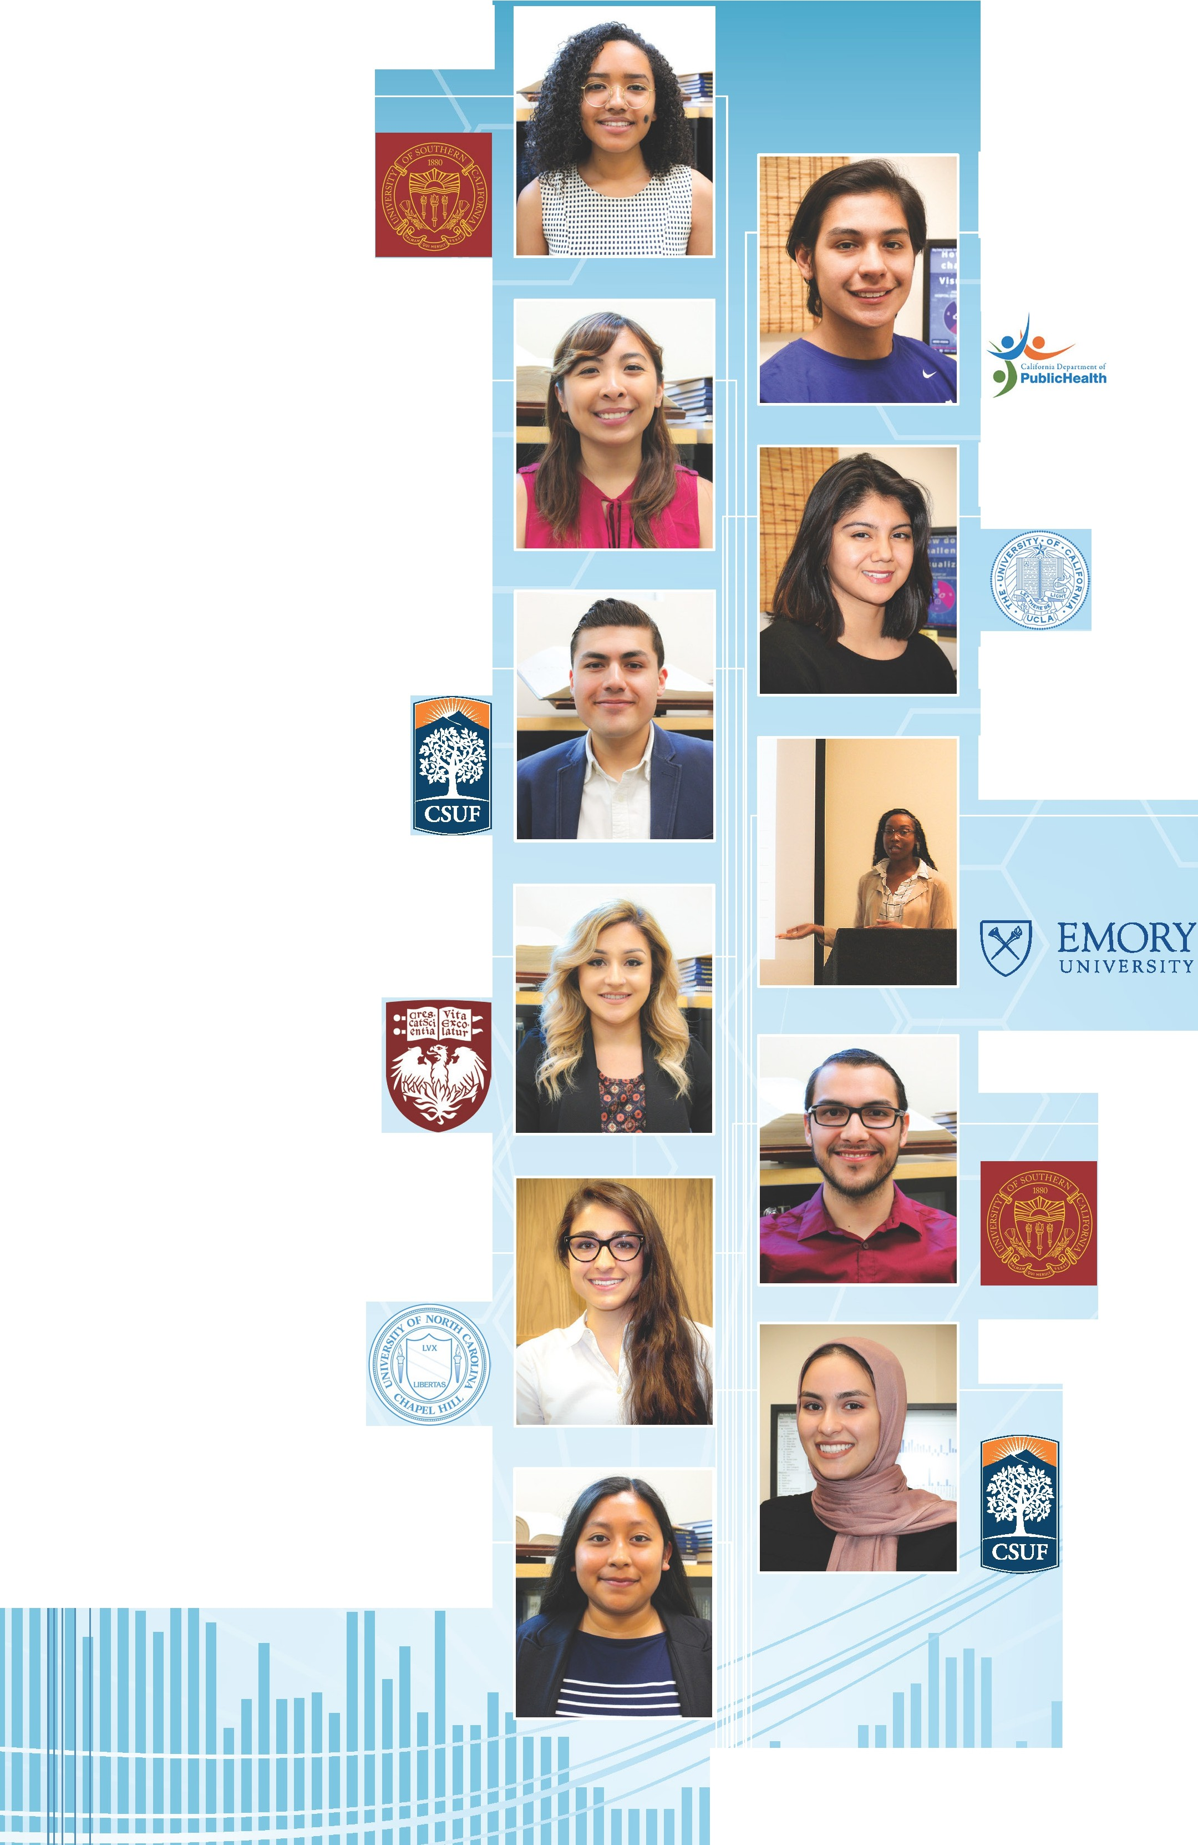


1111;

Emma Navajas
I University of North Carolina at Chapel Hill

Nooralhoda Sadeghi
California State University, Fullerton

Galilea Patricio
Clinical Research

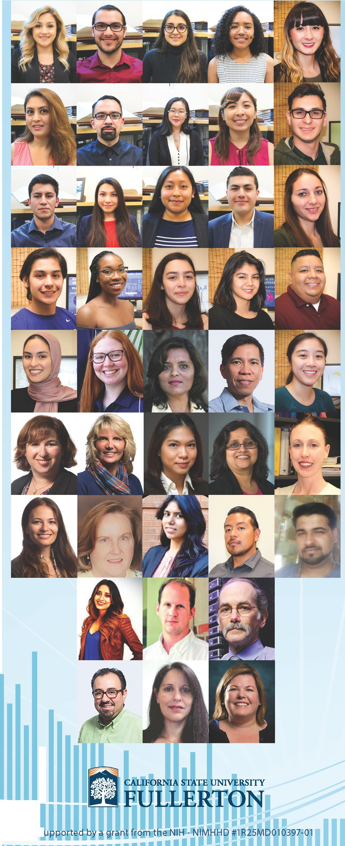
Big Data Discovery and Diversity - Research Education Advancement and Partnership (BD3-REAP) provides enriching research experiences and opportunities through exploration and understanding big data sources, diversity, computation, and analytics in efforts to improve health.

I
11111,
11111

