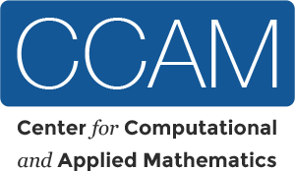
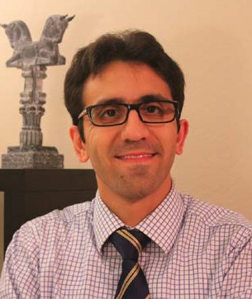
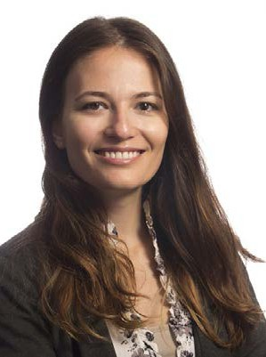
Title:
Share the Blame, Collaborate: Small Flies and Big Data

Professor Reza Ramezan
Mathematics Professor Parvin Shahrestani

Abstract:
Biological Science




How many disciplines does it take to save a fly’s life? Have you statisticians ever been eager to find a collaborator from another research area with problems and subjects more alive than your computer and textbooks? Have you scientists ever gotten stuck on a problem (say statis- tical?) for which you needed expert’s opinion? This talk discusses the collaborative journey of a biologist and a statistician who met through CCAM. They work together to solve problems in evolutionary genetics, combining experimental evolution, phenotype data, survival analysis, and computational statistics. The answer is 2!

When: Friday March 24, 2017 2p.m.
Where: MH-480
Light Refreshment will be served.
For information regarding seminars and workshops email: ccam@fullerton.edu

