












FUNCTIONAL BRAIN CONNECTIVITY ANALYSIS IN HUMAN CONNECTOME PROJECT DATA
SILVIA OROZCO








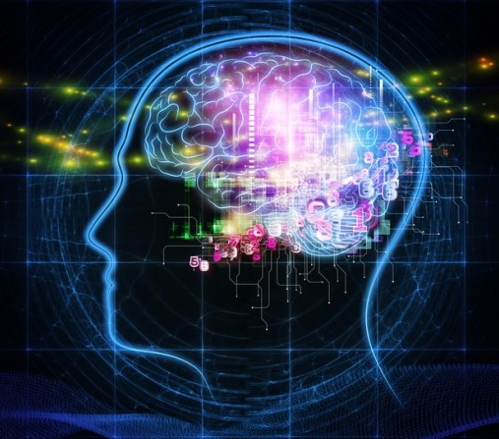
BIG DATA & NEUROIMAGING

As imaging technology improves, the amount of brain data increases

Images of the human brain provide large amount of information

HUMAN CONNECTOME PROJECT

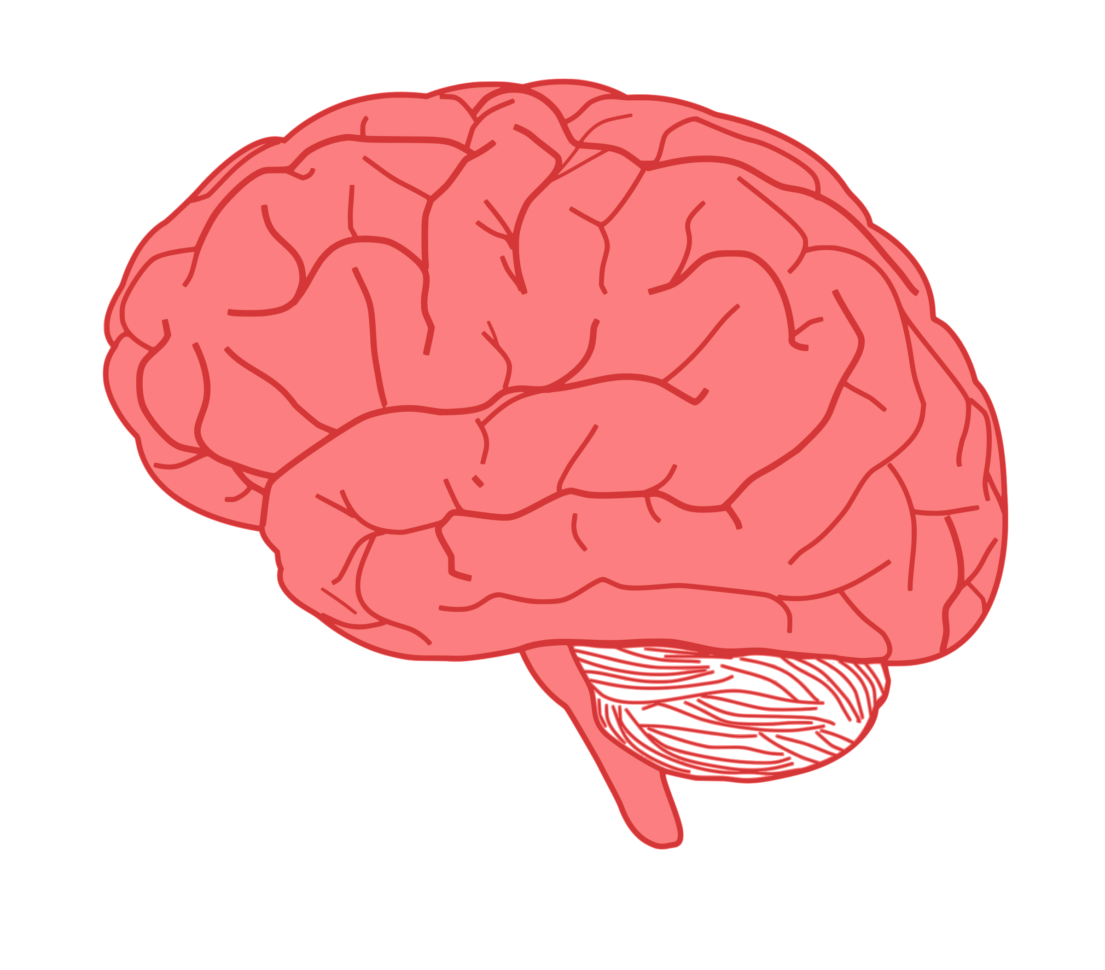
5-year, $40- million initiative to map the human brain networks

Connectome is complex and poorly understood
Goal: solve complexity with new Magnetic Resonance Imaging (MRI) Technology





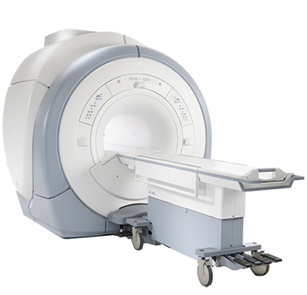
MEASURING FUNCTIONAL BRAIN CONNECTIVITY
- Functional Magnetic Resonance Imaging (fMRI)
- Resting-state fMRI
  - Blood-Oxygen-Level-Dependent (BOLD) Signal

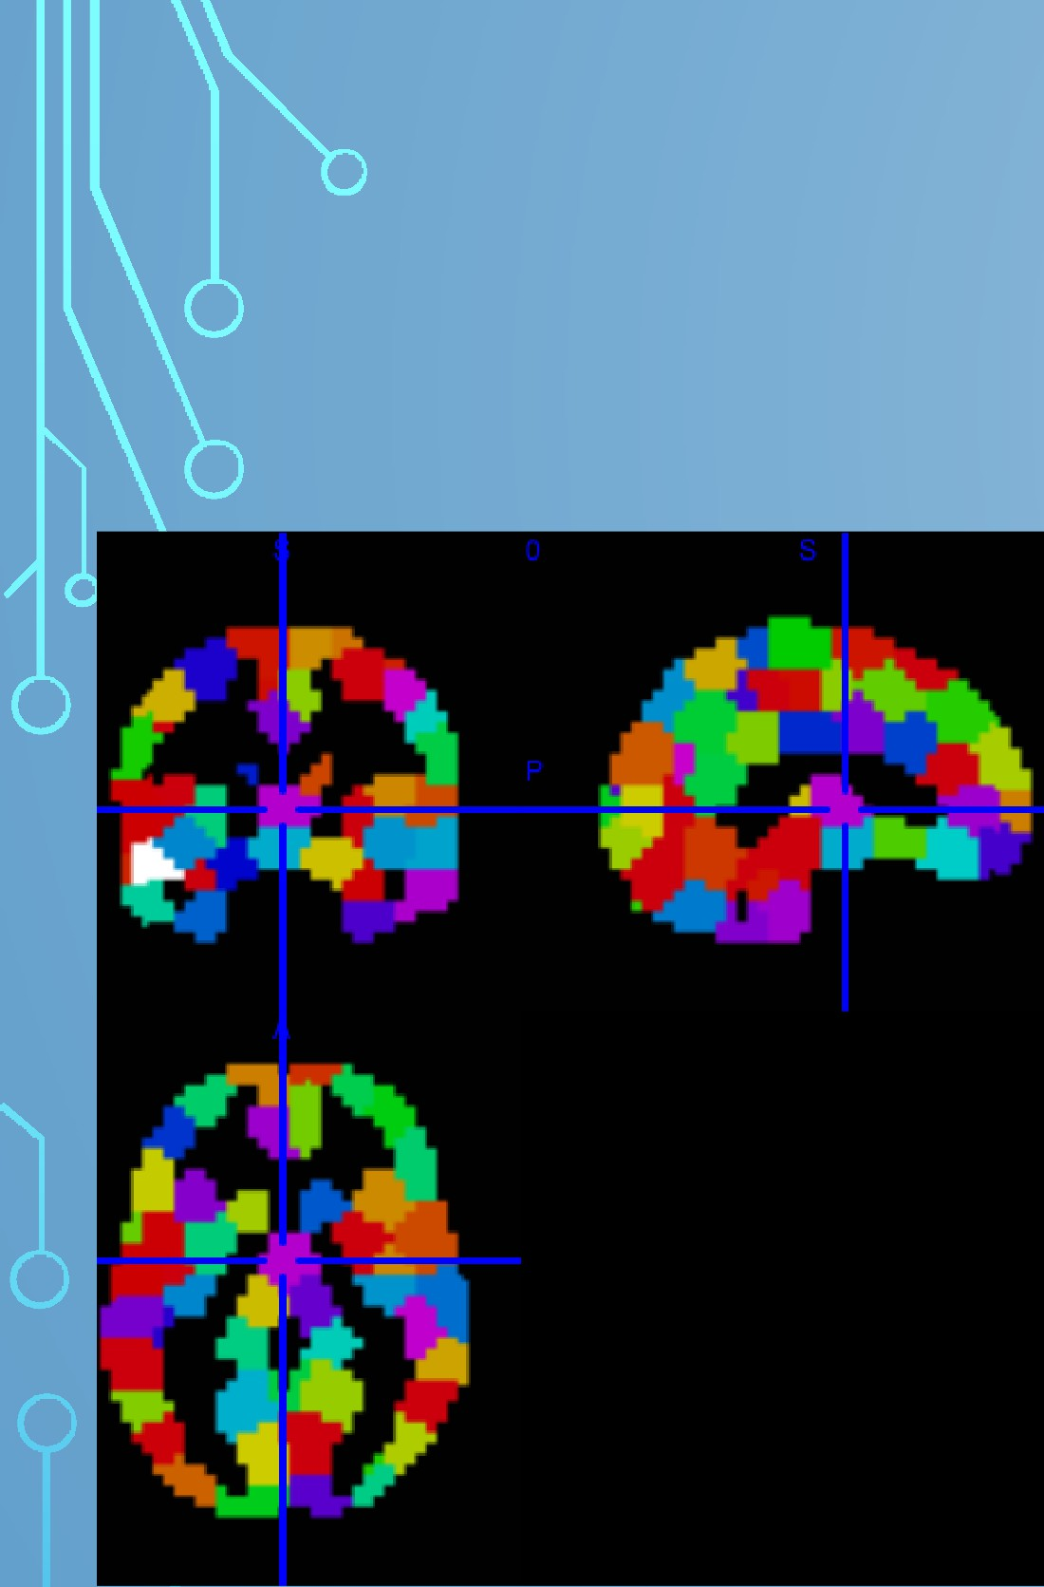

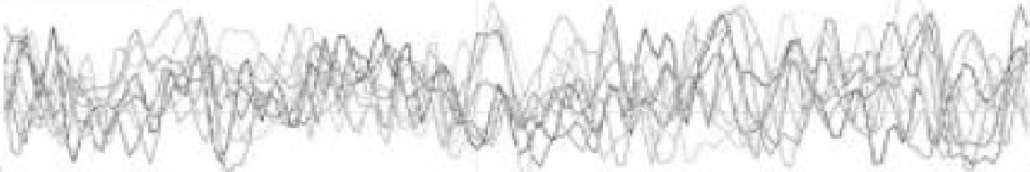
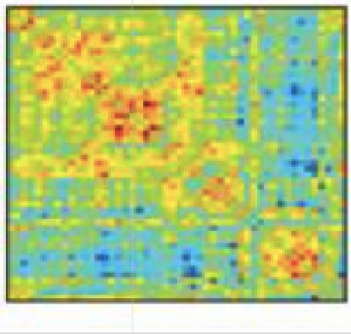
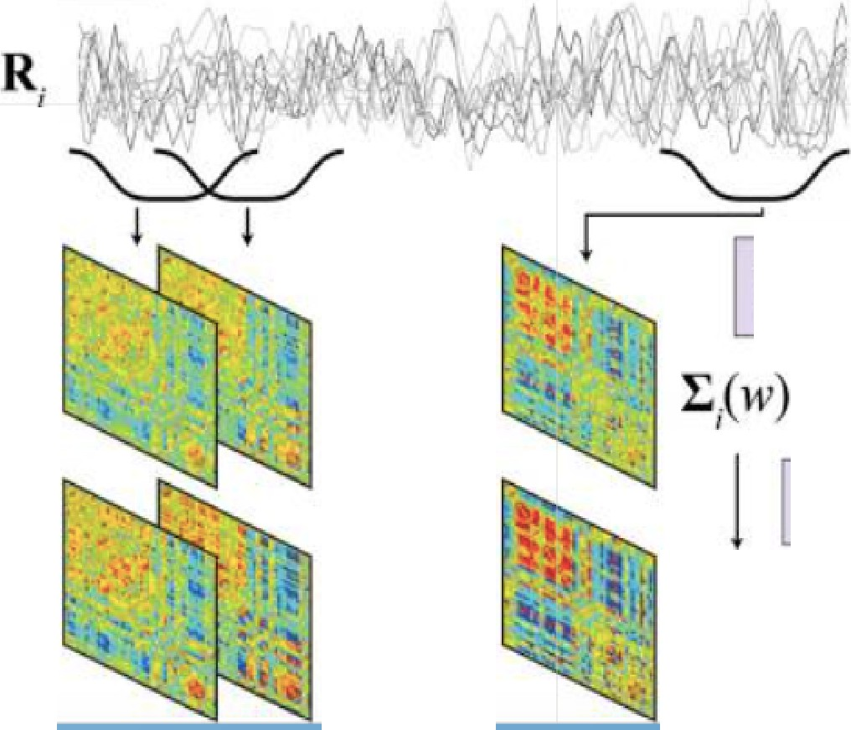
STATIONARY FC
[ DYNAMIC FC ]
ESTIMATE
COVARIANCE
I
FOR WINDOW 1-1 1 to II' ESTIMATE COVARIANCE
•••
REGULARIZE I:-1(w)
I
•••
:E_L1 W
I







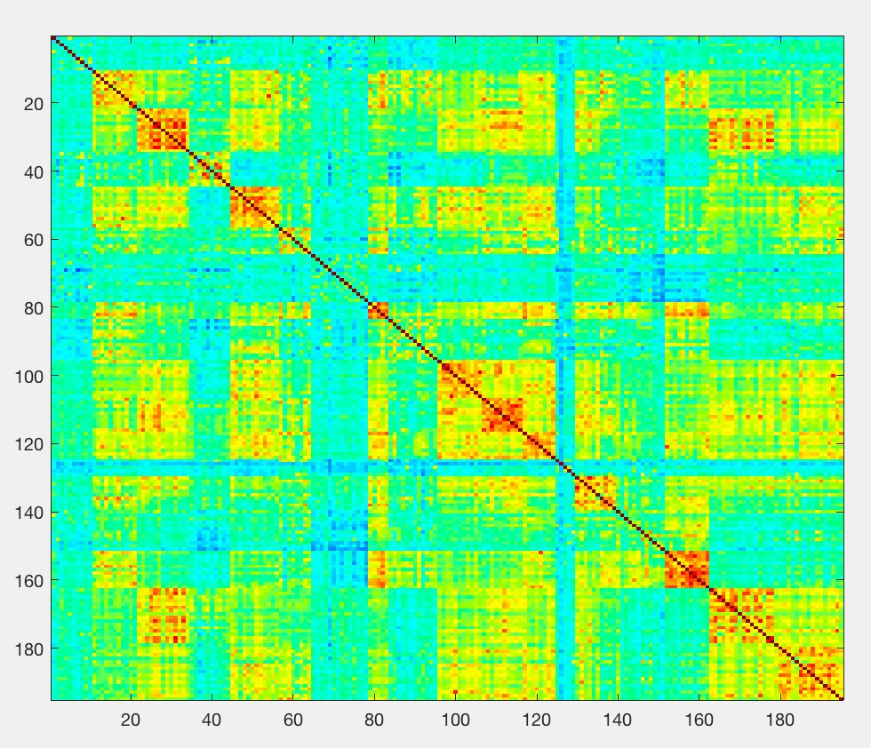
Stationary Functional Connectivity

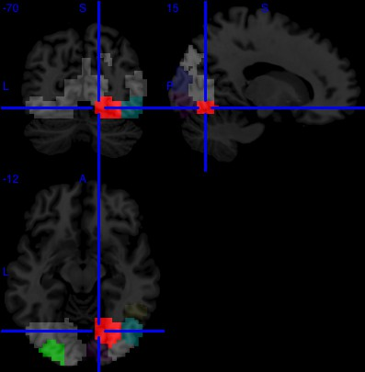
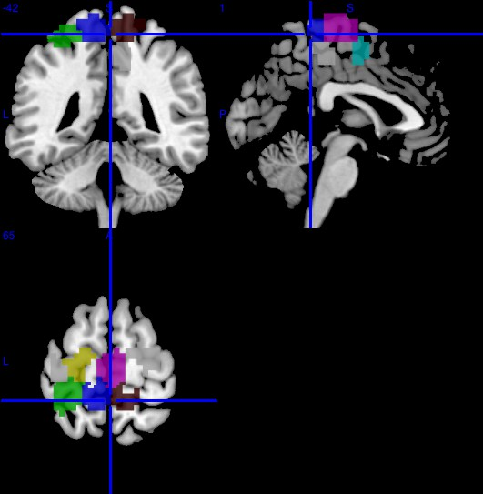
PRIMARY SENSORY (VISUAL & MOTOR)

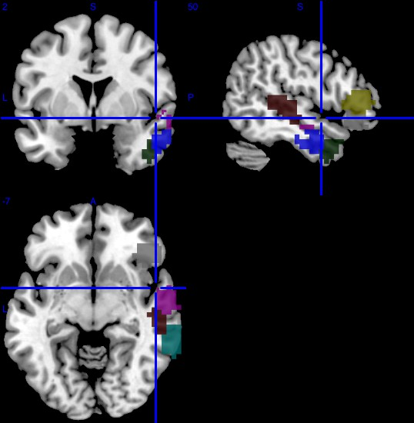
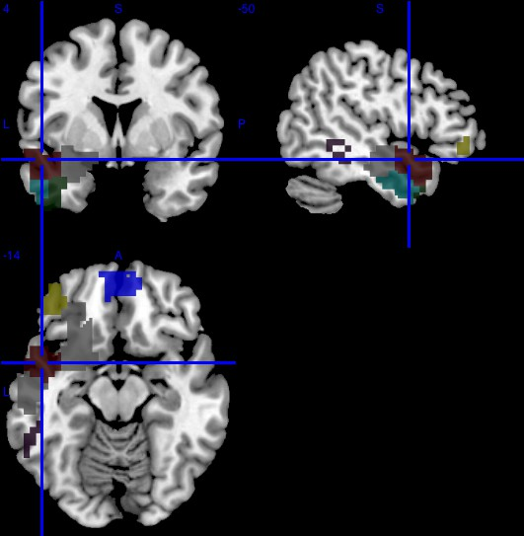
FRONTOTEMPORAL R/L LATERALIZATION

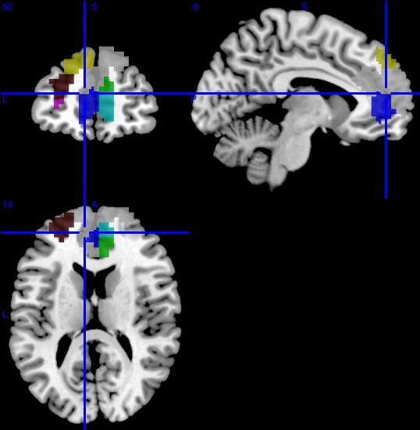
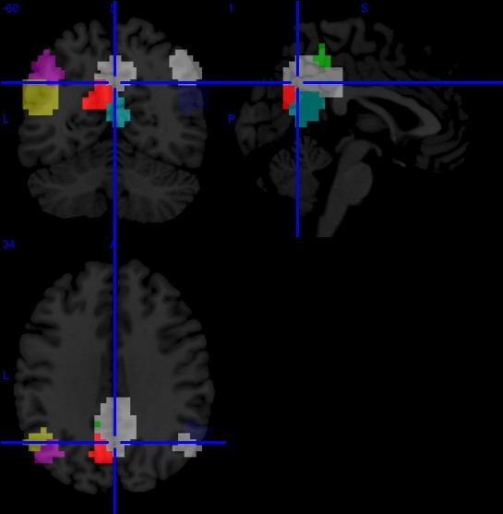
DEFAULT MODE NETWORK

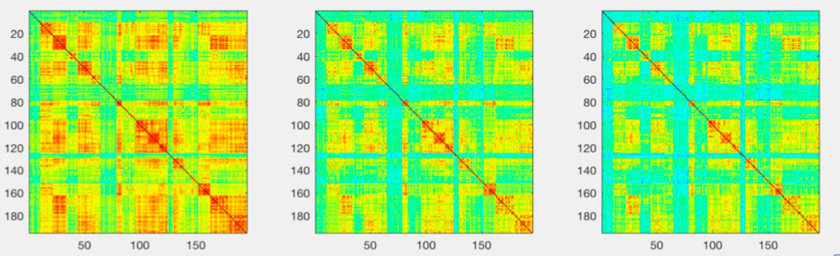
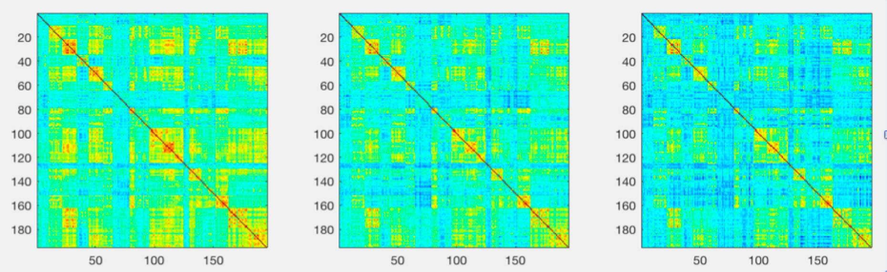
Dynamic Functional Connectivity

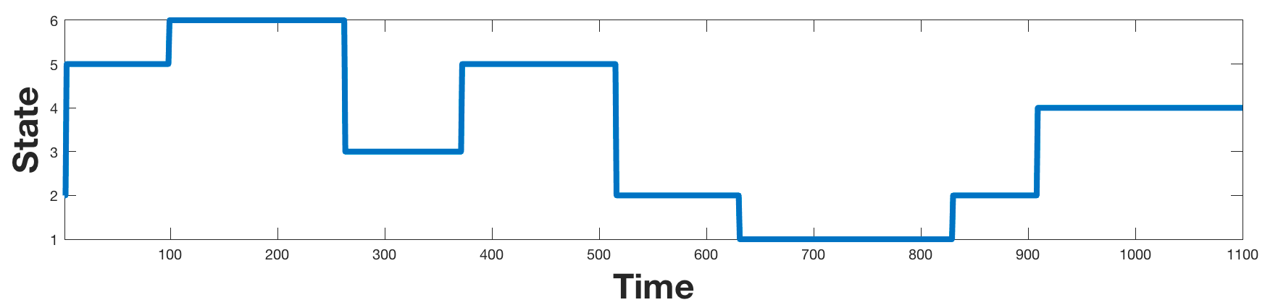
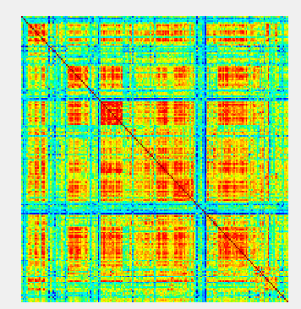
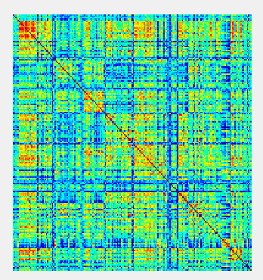
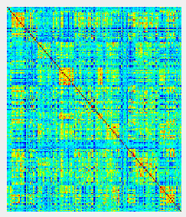
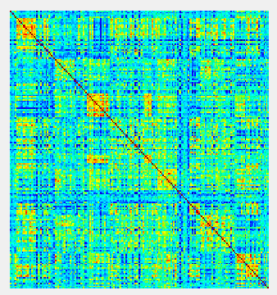
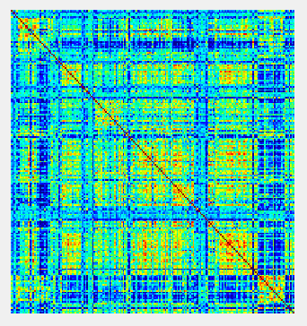
Dynamic Functional Connectivity

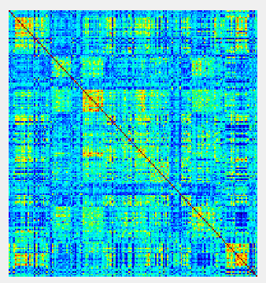
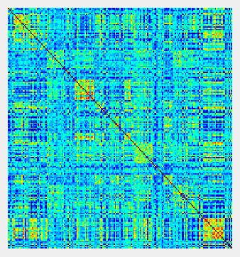

OUTLOOK
- Stationary Functional Connectivity
  - Less Clustering
- Dynamic Functional Connectivity
  - Focus on a specific network




ACKNOWLEDGEMENTS
- Dr. Jann
- Dr. Cuajungco
- Dr. Behseta
- Dr. McEligot
- USC

SOURCES
- Forcom, A. M. & Fletcher, P. C. (2007). Does the brain have a baseline? Why we should be resisting a rest state. Elsevier 37: 1073– 1082.
- Damoiseaux, J. S. & Greicius, M. D. (2009). Greather than the sum of its parts: a review of studies combining structural connectivity and resting-state functional connectivity. Brain Structure Function 213: 525 – 533.
- Allen, E. A., Damaraju, E., & Calhoun, V. D. (2014). Tracking whole-brain connectivity dynamics in the resting state. Cerebral Cortex 24(3): 663-676
- Cole, D.M., Smith, S. M. & Beckman, C. F. (2011) Advances and pitfalls in the analysis and interpretation of resting-state fMRI data. Frontiers in Systems Neuroscience 4(8): 1-15.
- Bardin, J. (2012). Making Connections. Nature (483): 395-398
- Logothetis, N. K. & Wandell, B. A. (2004). Interpreting the BOLD Signal. Physiology 66: 735- 769.

